Final Project Template: Request Defective Part Replacement

Question 1

Process Table: Defective Part Replacement (4 points)
Fill in the table below by reviewing the defective part replacement workflow. Ensure each process step is accurately represented with its corresponding symbol and dependencies. This will help you understand the sequence of actions and decision points within the process.
Process Step # | Process Step | Process Symbol | Dependencies
0 | **Start** | Start (Circle) | - (Marks the beginning)
1 | Customer requests service (Contact store, report defective part) | Rectangle | Process Step 0 (Start)
2 | Customer provides purchase details (Supply order # or receipt) | Rectangle | Process Step 1 (Customer requests service)
3 | Store verifies defect claim (Clerk inspects part/digital evidence) | Rectangle | Process Step 2 (Customer provides purchase details)
4 | Decision: Is Purchase Verifiable? | Decision (Diamond) | Process Step 3 (Store verifies defect claim)
5 | System checks inventory (Checks for replacement part availability) | Rectangle | Decision Step 4 (Is Purchase Verifiable? - Yes path)
6 | Decision: Is Replacement Part In Stock? | Decision (Diamond) | Process Step 5 (System checks inventory)
7 | Replacement is issued (Clerk initiates transaction, provides new part) | Rectangle | Decision Step 6 (Is Replacement Part In Stock? - Yes path)
8 | Decision: Does Part Show Misuse/Damage? | Decision (Diamond) | Process Step 7 (Replacement is issued)
9 | Confirmation provided (System generates confirmation receipt/email) | Rectangle | Decision Step 8 (Does Part Show Misuse/Damage? - No path)
10 | End - Replacement Issued | Decision (Diamond) | Process Step 9 (Confirmation provided)
11 | (Alternative Flow A1 Start) - No inventory available (System presents options) | Rectangle | Decision Step 6 (Is Replacement Part In Stock? - No path)
12 | (Alternative Flow A2 Start) - Purchase cannot be verified (Request denied) | Rectangle | Decision Step 4 (Is Purchase Verifiable? - No path)
0
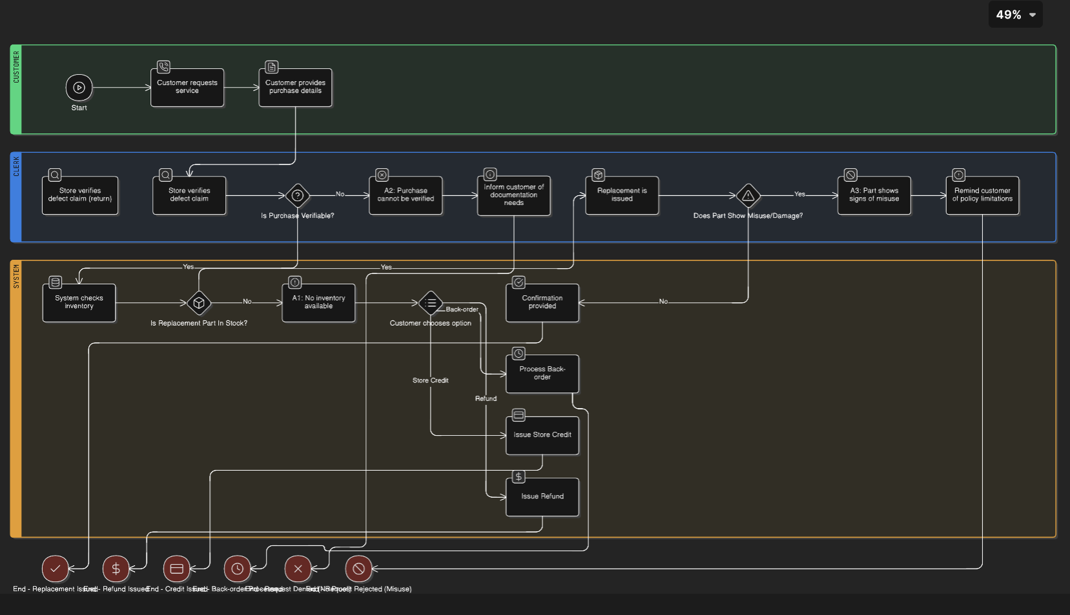

Question 2: Process Narrative: Defective Part Replacement (4 points)
Fill in this table with a detailed narrative of each process step. Include the responsible party and provide a clear description of each action, decision, and alternative path in the defective part replacement process.
Process Step | Process | Responsible | Description
1 | Customer requests service | Customer | This is the initial trigger point for the process. The customer contacts the auto parts store (in person, by phone, or through an online portal) to inform the store that a part they recently purchased is defective and requires replacement. This step initiates the entire replacement workflow.
2 | Customer provides purchase details | Customer | Following the initial request, the customer supplies specific details to verify their purchase. This typically includes providing the order number, receipt number, or presenting the original receipt. This information is crucial for the store to validate the transaction and check against their records.
3 | Store verifies defect claim | Clerk | The clerk, upon receiving the purchase details, takes action to confirm the defect claim made by the customer. This involves physically inspecting the returned part for signs of a manufacturing defect. If the request is made online, the clerk might review any digital evidence provided by the customer (e.g., photos, detailed description). The goal is to assess if the issue is indeed a defect.
4 | Decision: Is Purchase Verifiable? | Clerk | This is a critical decision point. Based on the information and evidence provided by the customer (from Step 2 and 3), the clerk makes a judgment. If the purchase details are confirmed and legitimate, they proceed down the "Yes" path. If the purchase cannot be verified (e.g., no valid receipt, order not found, outside policy window), they proceed down the "No" path, leading to Alternative Flow A2. This step ensures the request is valid and authorized.
5 | System checks inventory | System | Assuming the purchase was verifiable (from Step 4's "Yes" path), the system (e.g., inventory management or Point of Sale system) is queried to determine the availability of the specific replacement part. The system checks its database to see if an identical or equivalent part is currently in stock and ready for sale.
6 | Decision: Is Replacement Part In Stock? | System/Clerk | This is another key decision point. The system provides an output (or the clerk interprets the system's output) regarding part availability. If the replacement part is available, they proceed down the "Yes" path, allowing the process to continue towards issuing a replacement. If the part is not in stock, they proceed down the "No" path, initiating Alternative Flow A1, where alternative options must be considered.
7 | Replacement is issued | Clerk | Following the confirmation that the replacement part is in stock (from Step 6's "Yes" path), the clerk performs the final transaction. This involves retrieving the new part from inventory, processing the exchange in the system (potentially handling any price differences if applicable), and handing the new, non-defective part over to the customer.
8 | Decision: Does Part Show Misuse/Damage? | Clerk | This decision point occurs after the replacement part has been issued (Step 7). The clerk performs a final check on the returned defective part. They assess whether the damage or issue is due to manufacturing defect or if it shows signs of misuse, improper installation, or damage caused by external factors (not a defect). This is crucial for determining responsibility and policy adherence.
9 | Confirmation provided | System | Assuming the part did not show misuse/damage (from Step 8's "No" path), this step concludes the successful path of the basic flow. The system automatically or manually generates a confirmation for the customer. This could be a printed receipt, an email confirmation, or an on-screen message, indicating that the replacement transaction has been completed.
10 | End - Replacement Issued | N/A | Marks the formal conclusion of the process for the scenario where the replacement was successfully issued and confirmed. The customer has received the new part, and the store has processed the transaction.
11 | (Alternative Flow A1 Start) No inventory available (System presents options) | System/Clerk | This marks the entry point for Alternative Flow A1. Triggered by the "No" outcome in Step 6 (Is Replacement Part In Stock?). The system or clerk informs the customer that the requested replacement part is currently unavailable. The clerk then presents the customer with alternative options according to store policy: a full refund, store credit, or potentially placing the item on back-order (if the store offers this service and expects the part soon).
12 | (Alternative Flow A2 Start) Purchase cannot be verified (Request denied) | Clerk | This marks the entry point for Alternative Flow A2. Triggered by the "No" outcome in Step 4 (Is Purchase Verifiable?). The clerk informs the customer that their request cannot be processed because they cannot verify the original purchase. The clerk clearly explains the reason (lack of proof) and reminds the customer of the store's acceptable documentation requirements for future returns or replacements, formally denying the request.

Question 3

Reflection (2 points)
Use the space below to reflect on the process mapping and narrative exercise. Provide a short reflection of your learnings from this exercise (60 to 100 words).
**Reflection**

This exercise provided a valuable hands-on insight into how process documentation works. By mapping the defective part replacement workflow and creating the narrative, I learned how breaking down a real-world scenario into sequential steps and decisions clarifies the process significantly. It highlighted the importance of clear documentation for ensuring consistency, accuracy, and effective decision-making within a business operation, making complex procedures easier to understand and follow for everyone involved. This exercise underscored how structured processes improve operational efficiency.

